Practical - 10
Practical Title: Secure Login/Logout with Sessions, Role-Based Access, Timeout, and Remember-Me Token

Develop secure login and logout functionality using PHP sessions. Verify password using password_verify(), regenerate session ID after login, restrict dashboard access, implement role-based redirection, session timeout, and optional secure remember-me token.

Theory
1. Are sessions started and destroyed securely?
- Sessions should use secure, unpredictable session IDs and regenerate IDs after login to prevent session hijacking.
- Sessions should expire automatically after inactivity and have appropriate timeout limits.
- On logout, destroy the session completely and invalidate its session ID.
2. Is password_verify() used correctly?
- password_verify() correctly checks a password against its stored hash.
- It returns true if the password matches and false otherwise.
- It should be used with passwords hashed using password_hash().
3. Is unauthorized dashboard access blocked?
- Unauthorized users are blocked from accessing the dashboard through authentication.
- Role-based access control (RBAC) restricts access to authorized users only.
- Unauthorized access attempts are denied to protect sensitive data.
4. Is session timeout implemented?
- Yes, session timeout is implemented.
- Users are automatically logged out after a period of inactivity.
- Users must log in again to access protected pages.
5. Are admin and student users redirected to appropriate dashboards?
- Admin users are redirected to the Admin Dashboard after successful login.
- Student users are redirected to the Student Dashboard after successful login.
- Role-based redirection ensures each user accesses only their authorized features.

Implementation/Output/Result

My learning codes: https://drive.google.com/file/d/1CPP3uUq3gdKZxC3pFB7iheZVU7FCImSx/view?usp=drive_link

Evidence of Work (Screenshots)
Login page:
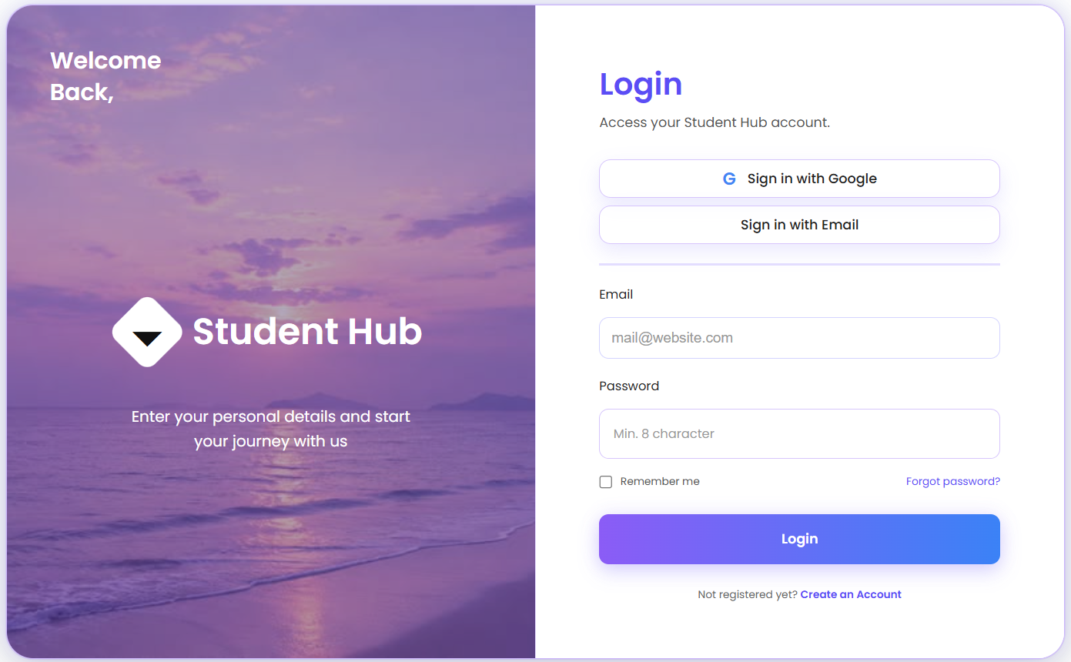
Invalid login:
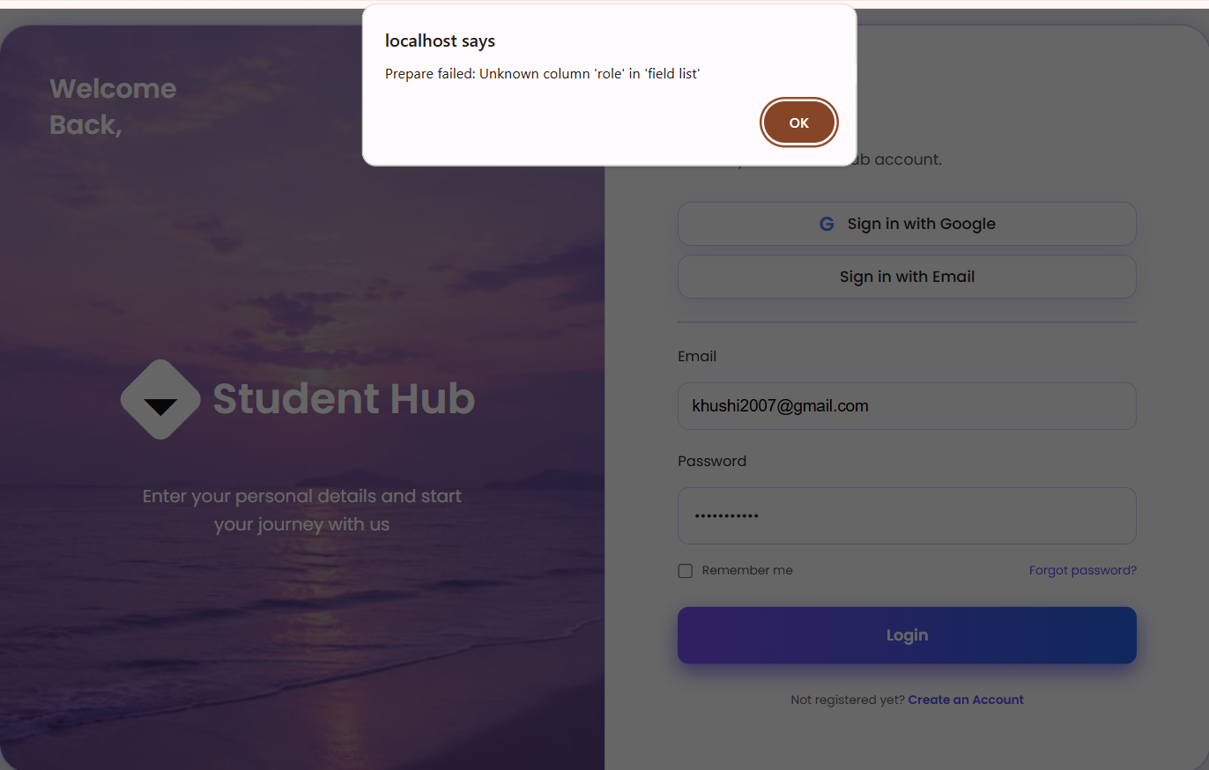
Successful authentication:
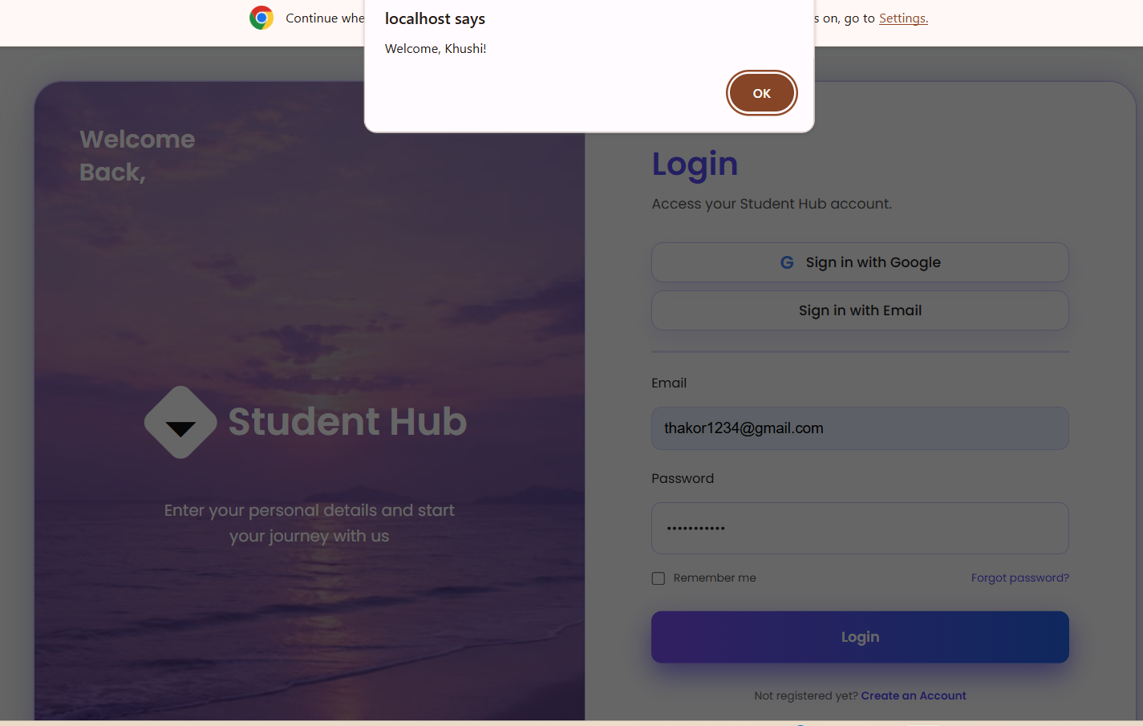
Dashboard:
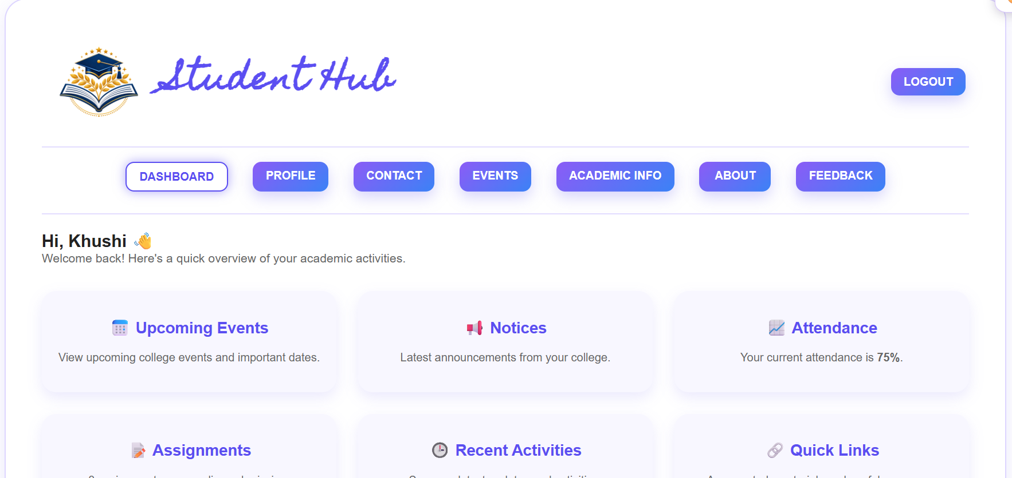

Back to the login page:
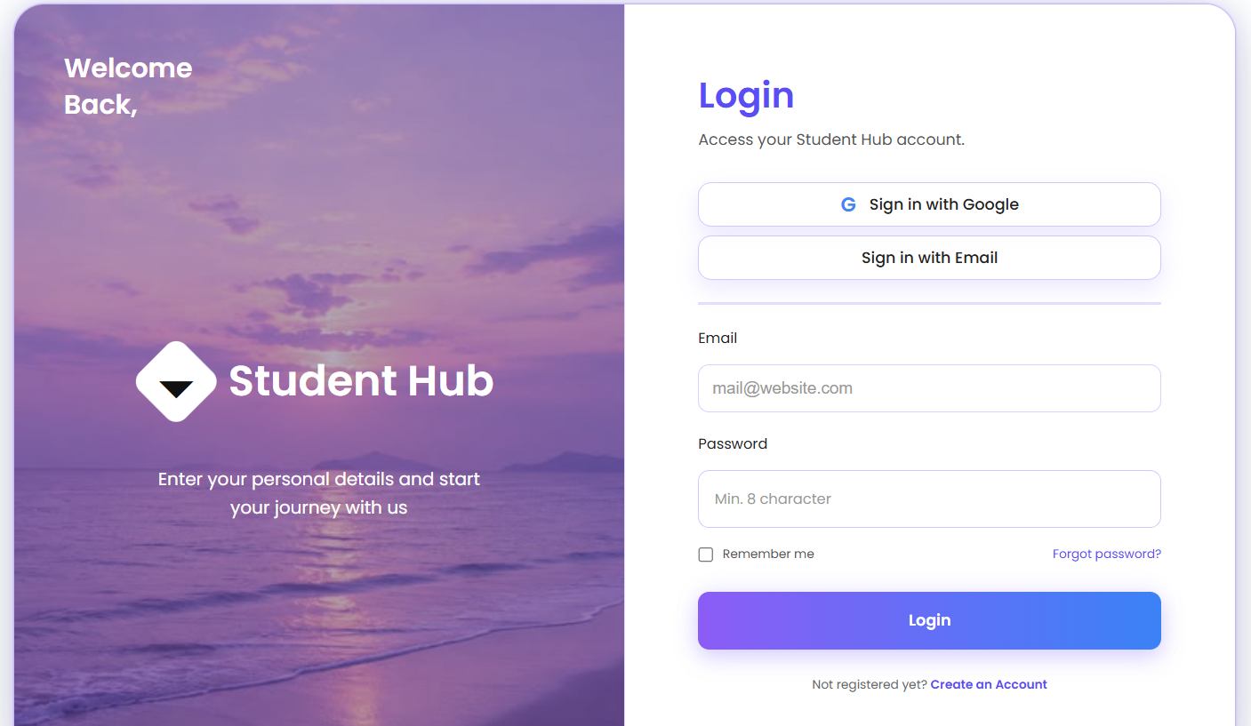

GitHub Repository Link:
Khushi-Thakor2007/Student-Hub-Portal

Challenges Faced:
- Managing sessions securely: regenerating the session ID after login and destroying the session fully on logout, so session hijacking and fixation are prevented.
- Getting the session timeout, role-based redirection and dashboard protection to work together, so that unauthorized users, expired sessions and wrong-role users were all blocked on every protected page.

Learning Outcomes:
- Learned to implement secure authentication in PHP using password_hash()/password_verify(), session ID regeneration, and proper session start and destroy handling.
- Understood how to enforce access control with role-based redirection (admin vs. student), inactivity timeout, and optional remember-me tokens to protect sensitive pages.

Faculty Remarks:

